🎓✨ AI Assisted Coding – Lab 17 ✨🎓

🌈 AI for Data Processing: Data Cleaning & Preprocessing

🎨 📘 Student Details
🏷 Field | 📌 Info
📅 Assignment | 17.2 / 24
📚 Course | AI ASSIT CODING
👨‍🎓 Name | Seetharam
🆔 Roll No | 2303A52440
👥 Batch | 34
🎓 Program | B.Tech – CSE (AI & ML)
📖 Year/Sem | 3rd Year – 2nd Sem

🎯✨ Lab Objectives
- 🔍 Clean raw datasets
- ⚡ Handle missing values
- 🧠 Encode categorical data
- 🚀 Prepare data for ML

🧩🔥 TASK 1 – Student Data Cleaning

💻🐍 Python Code (Color Style)
# 🔵 Import library
import pandas as pd
# 🟣 Load dataset
data = pd.read_csv("students.csv")
# 🟢 Handle missing values
data['marks'].fillna(data['marks'].mean(), inplace=True)
data['attendance'].fillna(data['attendance'].mean(), inplace=True)
data['department'].fillna("unknown", inplace=True)
# 🟡 Remove duplicates
data.drop_duplicates(subset='student_id', inplace=True)
# 🔴 Standardize text
data['department'] = data['department'].str.lower()
# 🟣 Encode data
data = pd.get_dummies(data, columns=['gender','department'])
print(data.head())

📸 Screenshots
👉 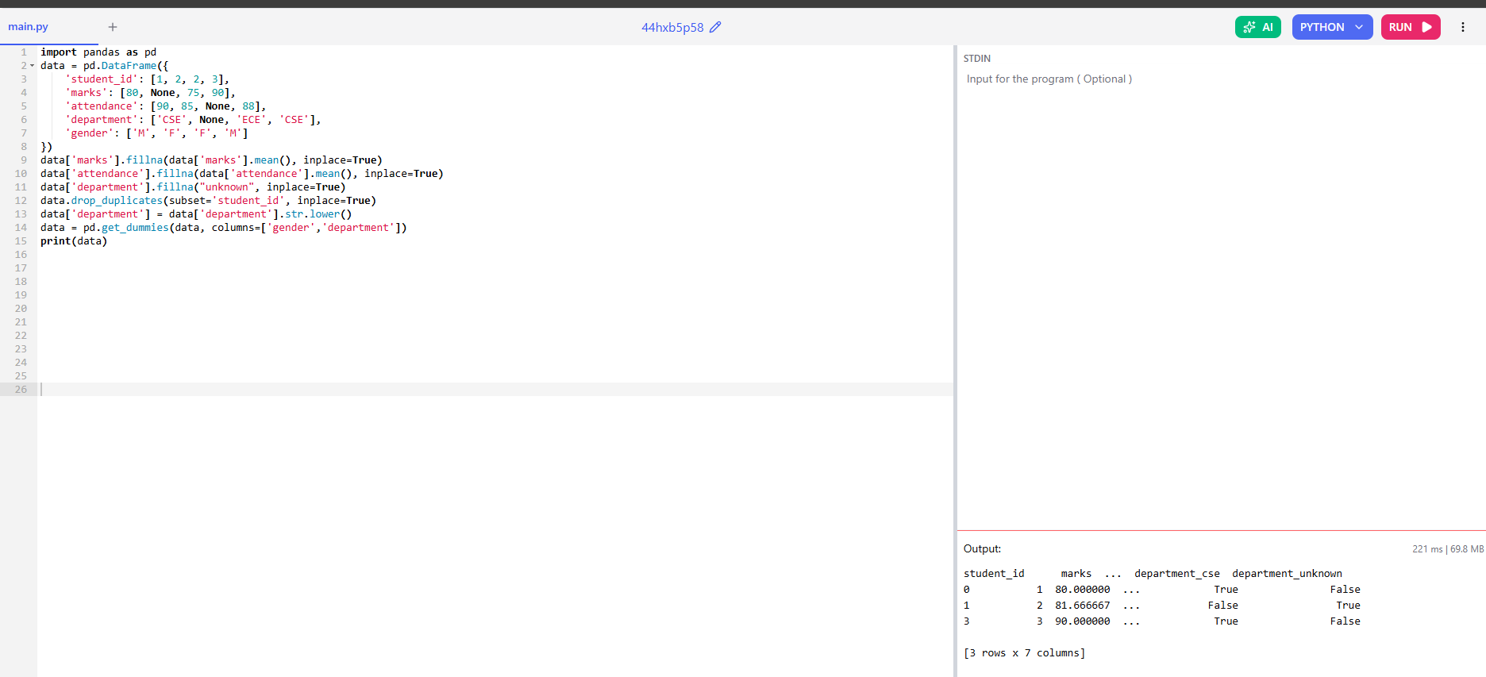

🧩🔥 TASK 2 – Financial Data Preprocessing

💻🐍 Python Code
# 🔵 Import
import pandas as pd
from sklearn.preprocessing import MinMaxScaler
# 🟣 Load
transactions = pd.read_csv("transactions.csv")
# 🟢 Convert date
transactions['date'] = pd.to_datetime(transactions['date'])
# 🟡 Create features
transactions['month'] = transactions['date'].dt.month
transactions['year'] = transactions['date'].dt.year
# 🔴 Normalize
scaler = MinMaxScaler()
transactions['amount'] = scaler.fit_transform(transactions[['amount']])
print(transactions.head())

📸 Screenshots
👉 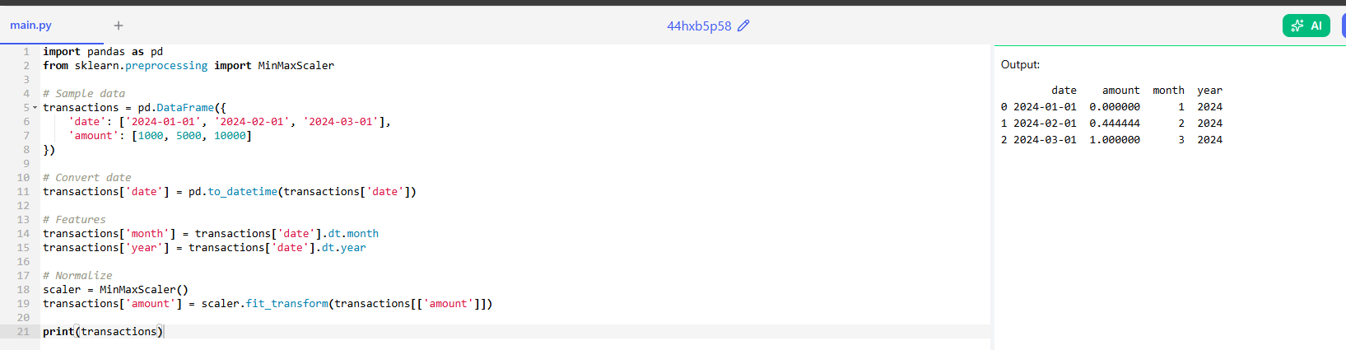

🧩🔥 TASK 3 – Sensor Data

💻🐍 Python Code
# 🔵 Import
import pandas as pd
from sklearn.preprocessing import StandardScaler
from sklearn.model_selection import train_test_split
# 🟣 Load
data = pd.read_csv("sensor_data.csv")
# 🟢 Fill missing
data.fillna(data.mean(numeric_only=True), inplace=True)
# 🟡 Encode
data = pd.get_dummies(data, columns=['sensor_status'])
# 🔴 Scale
scaler = StandardScaler()
data[['temperature','humidity','air_quality_index']] = scaler.fit_transform(
data[['temperature','humidity','air_quality_index']]
)
# 🟣 Split
train, test = train_test_split(data, test_size=0.2)
print(train.head())

📸 Screenshots
👉 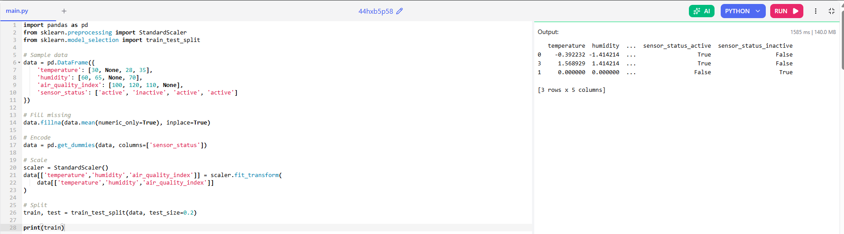

🧩🔥 TASK 4 – Traffic Data Cleaning

💻🐍 Python Code
# 🔵 Import
import pandas as pd
# 🟣 Load
traffic = pd.read_csv("traffic_data.csv")
# 🟢 Clean text
traffic['road'] = traffic['road'].str.lower()
# 🟡 Fill missing
traffic['traffic_density'].fillna(traffic['traffic_density'].mean(), inplace=True)
# 🔴 Remove duplicates
traffic.drop_duplicates(inplace=True)
# 🟣 Normalize
traffic['speed'] = (traffic['speed'] - traffic['speed'].min()) / (traffic['speed'].max() - traffic['speed'].min())
print(traffic.head())

📸 Screenshots
👉 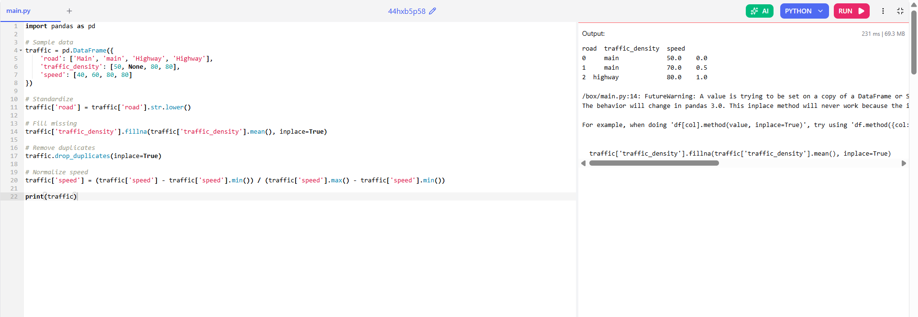

🧩🔥 TASK 5 – Social Media Cleaning

💻🐍 Python Code
# 🔵 Import
import pandas as pd
import re
# 🟣 Load
posts = pd.read_csv("social_media_posts.csv")
# 🟢 Remove nulls
posts.dropna(subset=['text'], inplace=True)
# 🟡 Clean text
def clean_text(text):
text = re.sub(r"http\S+", "", text)
text = re.sub(r"[^a-zA-Z ]", "", text)
return text.lower()
posts['clean_text'] = posts['text'].apply(clean_text)
# 🔴 Feature
posts['word_count'] = posts['clean_text'].apply(lambda x: len(x.split()))
print(posts.head())

📸 Screenshots
👉 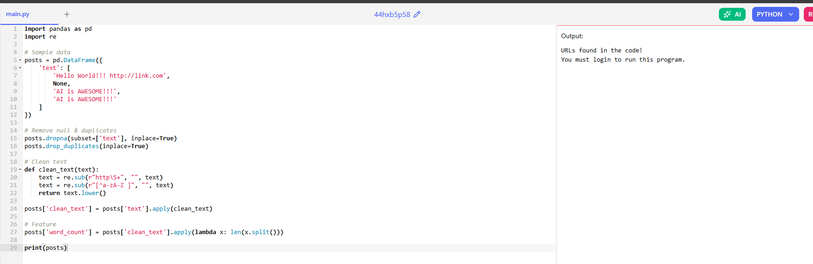

📝✨ Explanation
Each task cleans noisy data, improves structure, and prepares it for ML models.

🏁🔥 Conclusion
This lab shows how Python + AI helps automate data cleaning and improves dataset quality for better model performance.

